Franklin County Public Schools Volunteer
Newsletter

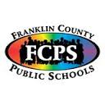zzzzzzz

Sept/ Oct 2013
Dropout Prevention/Volunteer
Coordinator
Kathleen Campbell
(502) 695-6790
(502) 695-6700

Dear Community Leaders and Volunteers,
What is the Mentoring Program?
Student mentoring at Franklin County Public Schools is defined as a one-to-one relationship between a youth and an adult that occurs over a prolonged period of time. The mentor provides consistent support, guidance, and concrete help to a student who is in need of a positive role model. Students involved in the mentoring program may be going through a difficult and/or challenging situation, a period of life in which they need extra support, or they may simply need to have another significant adult present in their life. The goal of student mentoring is to assist students involved in the mentoring program to gain the skills and confidence to be responsible for their own futures.
An adult interested in becoming a student mentor must be someone who will be a positive influence in a child’s life. The most crucial role for a student mentor is to be an adult who has time for a child, who cares about that child and who believes in that child1
The school asks that a student mentor spend a minimum of one hour a month with their child. This relationship between the student and mentor takes place during the school day at the child’s school.
If you would like more information on becoming a mentor contact Kathleen Campbell at (502) 695- 6790
All mentors must get a background check and have 3 trainings (all free of charge)

Franklin County Public Schools are grounded in the principles of community involvement and lifelong learning. Members of the community must work together to meet the needs of students.

With that being said, it is with great honor and privilege that I have been chosen to be Franklin County Public School’s Dropout Prevention/ Volunteer Coordinator. I look forward to getting to know each and every one of you and becoming part of this wonderful community.

My goal is to involve the entire population of Franklin County in the development of a truly educative community.

Should you have any questions don’t hesitate to call or e-mail me at Kathleen.Campbell@franklin.kyschools.us

“Never doubt that a small group of thoughtful committed citizens can change the world; indeed, it's the only thing that ever has.” – Margaret Mead

Sept. /Oct. dates to remember
Sept 9th | Board Meeting – Western Hills
Sept 17th | Career Day - Bridgeport Elem
Sept 19th | Career Day – Bridgeport Elem  Western Hills Blood Drive
Sept 20th | PD – No School
Sept 24th | Bridgeport – Reading Night
Oct.7th to the 11th | Fall Break
Oct. 14th | Board Meeting - FCHS
Oct. 28th | Staff/Conference Day – No School
Oct.30 | Breakfast with Books- Bridgeport
Oct.31st | Happy Halloween

Volunteer Spotlight
Carmen Inman
Carmen works tirelessly for the needs of Franklin County students. She mentors, works with FRYSCs and facilitates the “Reality Store” that teaches soft skills to 8th grade students.
Franklin County Schools thank you.

If you like your community or school event on Franklin County Public Schools Community and Volunteer Newsletter. E-mail Kathleen a request at: Kathleen.Campbell@franklin.kyschools.us

Community Support Needed for the Backpack Snack Program
I want to take a moment to give you statistics of children and families in Kentucky that go hungry every day:
In the U.S.: 36.2 million people live in households considered to be food insecure. Of these 36.2 million, 23.8 million are adults (10.6 percent of all adults) and 12.4 million are children (16.9 percent of all children)
In Kentucky: Kentucky ranks 8th highest in the nation for poverty. 12.7 million of Kentucky children are food insecure. That means 2 out of every 10 children go hungry.
FRYSC Coordinator Pamela Tate wants to lower these statistics. In 2006 she started a program called “Backpack Snack”. Every week students gets a backpack of nutritious food on Friday to sustain them over the weekend. The program has grown in multitudes, supplying 200 + students in Frankfort and Franklin County and the numbers are growing every day. From the beginning of the Backpack Pack program the goal has been to make this a community endeavor, enabling those who would like to assist in feeding the children we serve. There are several ways anyone in the community can assist in making sure no child will have to worry where their next meal will be coming from. Here are ways you can help.
Food drives or donations
Packing of the food for weekly delivery
Supplying Backpacks
Monetary donations to the Backpack Snack Program c/o Pamela Tate 300 Copperleaf Blvd. Frankfort, KY 40601
Delivering food to a central location for packing
Delivering food to the schools
If you would like to volunteer or have any questions call Pamela Tate at (502)352-2998 or (502) 875-8409. E-mail: Pamela.tate@franklin.kyschools.us

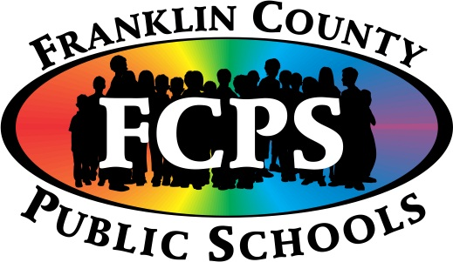 Franklin County Public Schools
Mission Statement
The mission of the Franklin County Public Schools is to educate students in a community-involved learning environment that ensures all students will achieve their greatest individual potential in order to succeed in a global society.

